Experiment – 8

Create a Virtual Machine with 1 CPU, 2GB RAM and 15GB storage disk using Type 2 Virtualization Software using Vmware workstation.
AIM:
To create a VM with specific hardware configuration using VMware Workstation.
SOFTWARE REQUIRED:
VMware Workstation 17, Ubuntu ISO, Host OS: Windows
PROCEDURE:
1.Open VMware Workstation 17 from the Start menu to access the virtualization environment on the host system.
2.Initiate the creation of a new virtual machine by selecting the option to create a new VM and choose the “Typical (recommended)” configuration to simplify the setup process.
3.Select the operating system installer by choosing the installer disc image file (ISO) option, then browse and select the Ubuntu ISO file to prepare for installation.
4.Assign a suitable name such as “Virtual Machine Ex-13” to the virtual machine and choose an appropriate storage location on the host system before proceeding to the next step.
5.Configure the virtual hard disk settings by accessing the Hard Disk options and setting the disk capacity to 15 GB to allocate sufficient storage for the guest operating system.
6.Adjust the hardware configuration by setting the memory allocation to 2048 MB (2 GB) under the Memory settings, and then configure the processor settings by selecting one processor with one core per processor to define the VM’s CPU resources.
7.Save the configuration by clicking OK and power on the virtual machine to begin the operating system installation process.

IMPLEMENTATION:



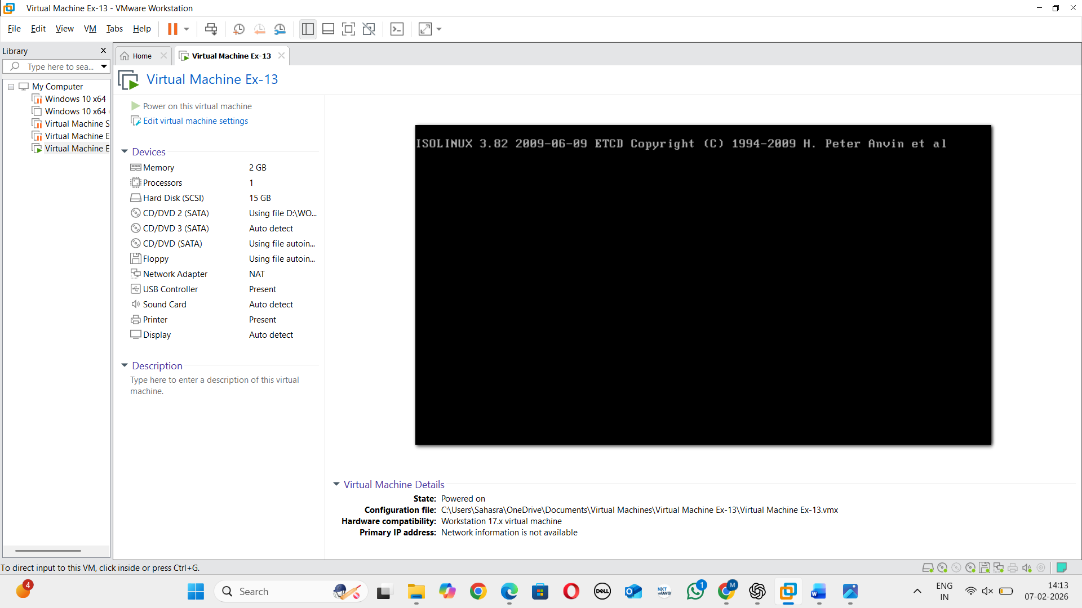

RESULT:
A virtual machine with 1 CPU, 2GB RAM and 15GB storage is created successfully

